Group C
Wendy Bronson
Eric Sengvanhpheng
William Judd
Luis Cortez
Martha Guzman
July 22, 2026
Database Development and Use
Module 10.1 Milestone #3
Case Study: Bacchus Winery

Project Overview
For Milestone #3, Group C created three business reports using information stored in the Bacchus Winery database. Each report retrieves data from multiple tables and provides information that could help management make decisions about suppliers, wine sales, employee workloads, production, and inventory.

Report 1: Monthly Supplier Delivery Performance
This report summarizes supplier deliveries by month and calculates the average number of days that deliveries arrived early or late. It can help Bacchus Winery identify suppliers that may be having delivery problems and determine whether late shipments could affect production.
A negative number means the delivery arrived early, zero means it arrived on time, and a positive number means it arrived late.
Figure 1Monthly Supplier Delivery Performance Report
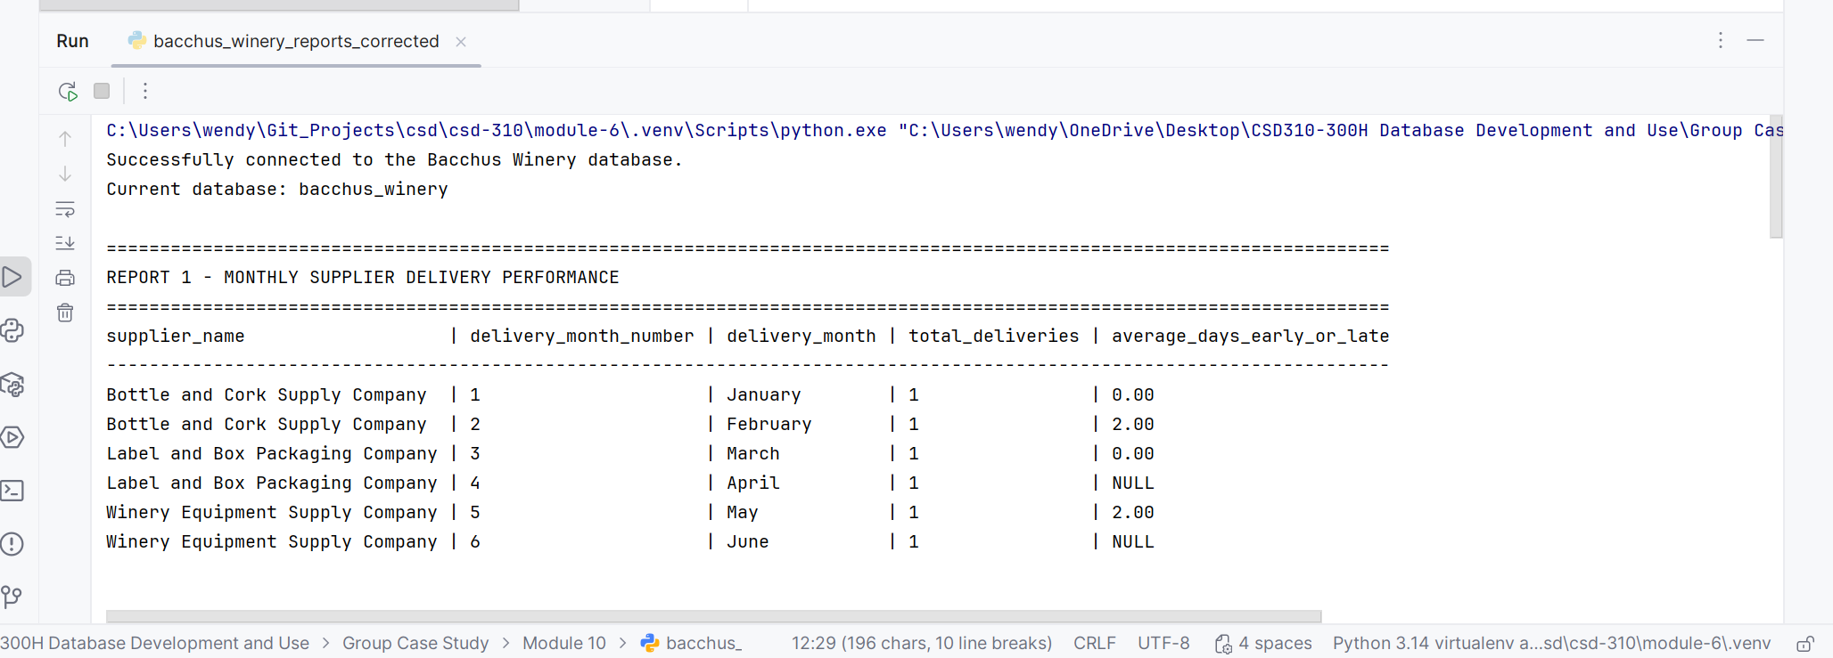

Report 2: Wine Sales by Distributor
This report shows the number of bottles ordered and the total sales amount for each wine and distributor. It allows management to see which wines are selling the best and which distributors are purchasing the most product. This information could help with production planning, inventory levels, and future sales efforts.

Figure 2 Wine Sales by Distributor Report
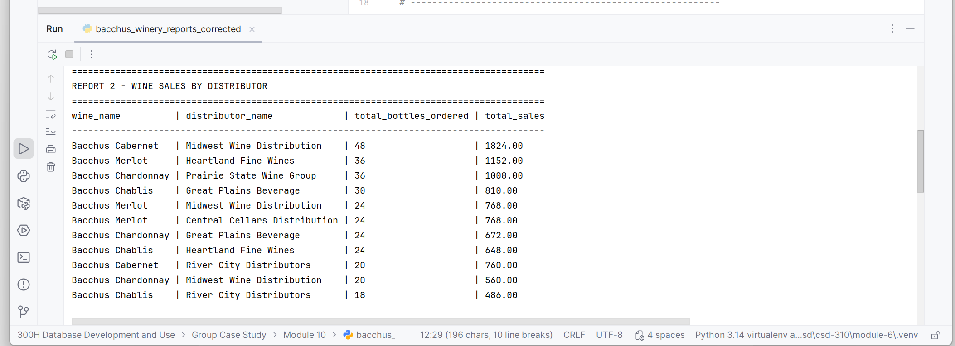

Report 3: Employee Hours for the Last Four Quarters
This report shows the total hours worked by each employee during the four most recent calendar quarters stored in the database. It gives management a way to compare employee workloads from quarter to quarter and identify possible staffing needs or changes in workload.
This report also addresses the instructor’s feedback from Milestone #2 about including employee hours for the last four quarters.

Figure 3 Employee Hours for the Last Four Quarters
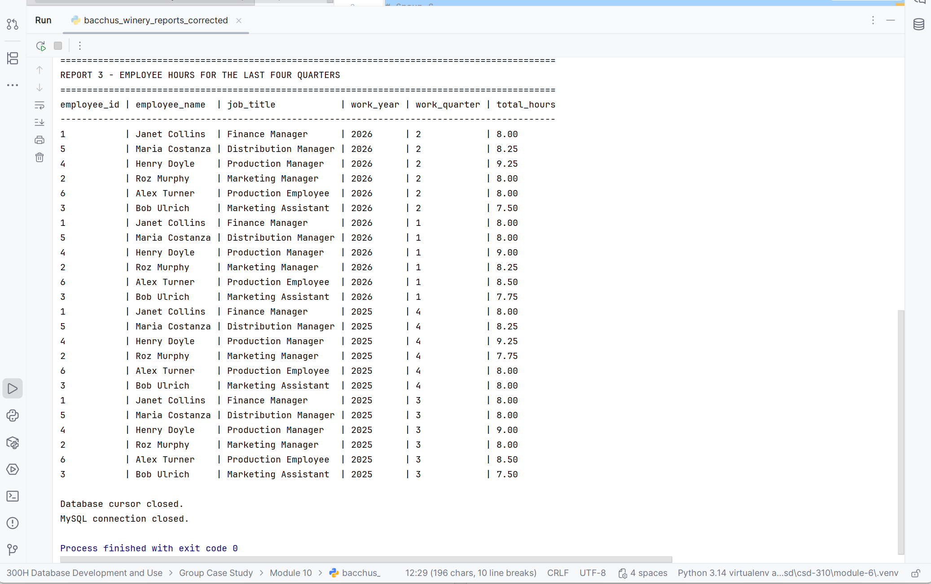

Revised Entity-Relationship Diagram
The revised ERD reflects the final structure of the Bacchus Winery database. It includes the tables, primary keys, foreign keys, and relationships used by the three business reports.
